*Florida International University*

*School of Computing and Information Sciences*

Software Engineering Focus

Feature Document

User Story #155

**Team Member:**

Giselle Pacheco

**Product Owner(s)**:

Mohsen Taheri

**Mentor(s)**:

Mohsen Taheri

**Instructor**: Masoud Sadjadi

**User Story** Add assignment.

* As a User I would like to be able to add assignments so I can keep track of assignments

Acceptance Criteria

* Have input for assignment name, and due date
* Have a done button that once pressed adds assignment to a list
* Hit the assignment endpoint in order to add the assignment

**Use Case** #**155– Add Assignment**

Details:

Actor: Student

Pre-conditions:

1. Student is logged in
2. Student has created a class
3. Student has selected a school

Description:

1. Use case begins when student clicks add assignment button
2. System displays a Form
3. Student selects a NEAT class
4. Student selects an assignment
5. Student clicks the done button
6. Use case ends when student sees new assignment displayed on assignment dashboard

Post-conditions:

1. Student sees a list of assignment with the new assignment added to the list

Alternative Courses of Action

1. Student selects an Manual Class
2. Student enters assignment name

Exceptions:

Related Use Cases:

**Use Case Diagram**

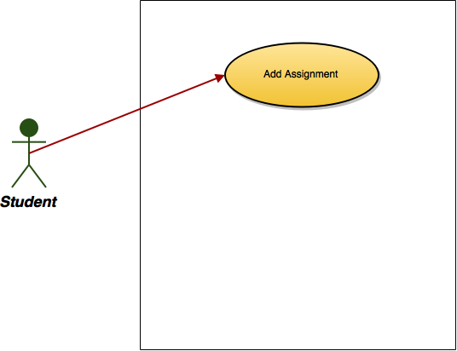

**Sequence Diagram**

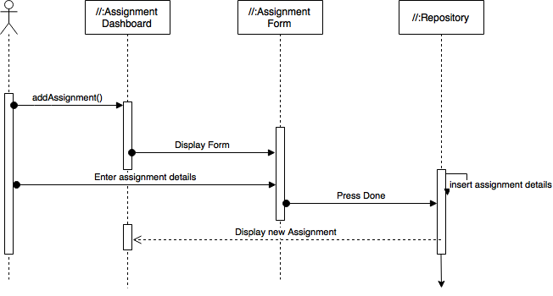

**Class Diagram**

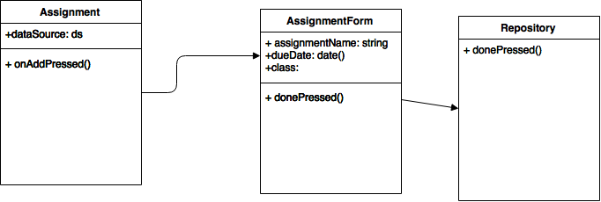

**Unit Test**

**Test Case 1 (Sunny Day)**

**Purpose**

* Ensure that a user can add an assignment

**Precondition**

* User is logged in
* User has added a class
* User is part of a school

**Input**

* Class is selected
* Assignment Name
* Due date of the assignment

**Expected Result**

* User can see an added assignment on the dashboard

**Actual Result**

* Added assignment on the dashboard

**Test Case 2 (Sunny Day)**

**Purpose**

* Ensure that there is a default due date

**Precondition**

* User is logged in
* User has added a class
* User is part of a school

**Input**

* User inputs an assignment name

**Expected Result**

* Assignment is added with the default due date

**Actual Result**

* Assignment is added

**Test Case 3 (Rainy Day)**

**Purpose**

* Ensure that if a user does not enter an assignment name, assignment is not added

**Precondition**

* User is logged in
* User has Selected a manual class
* User is part of a school

**Input**

* Due date of the assignment

**Expected Result**

* App stays on the Assignment form page

**Actual Result**

* App stays on assignment page

**Visual User Guide**

